**Assignment 1- Mobile application**

**Name :**Nauman Irshad Ali Shah

L1F22BSCS**0122**

**Section :** E11

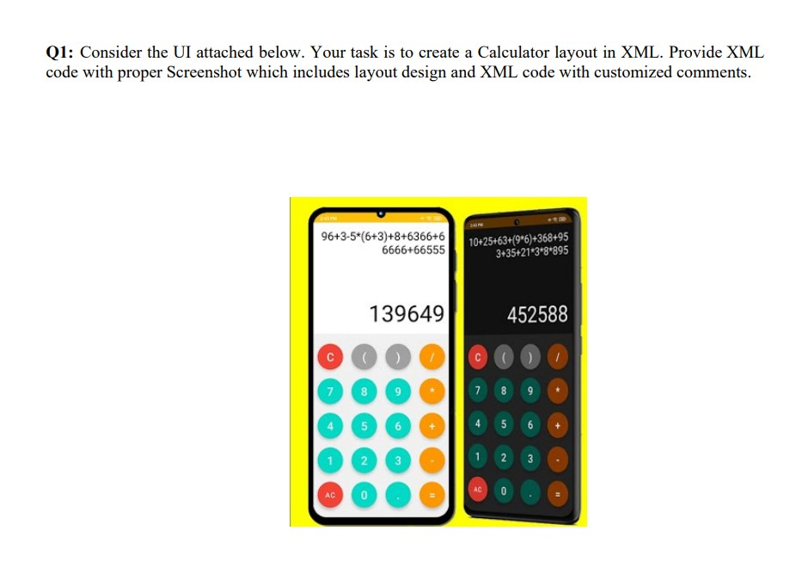

**LAYOUT SCREEN SHOTS.....**

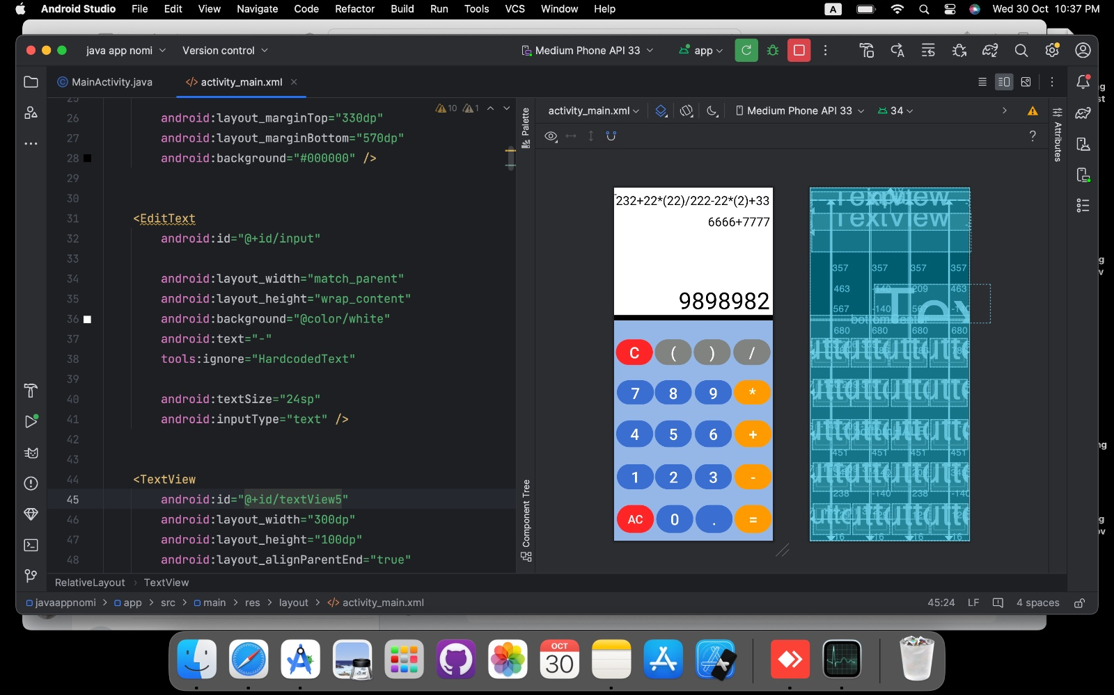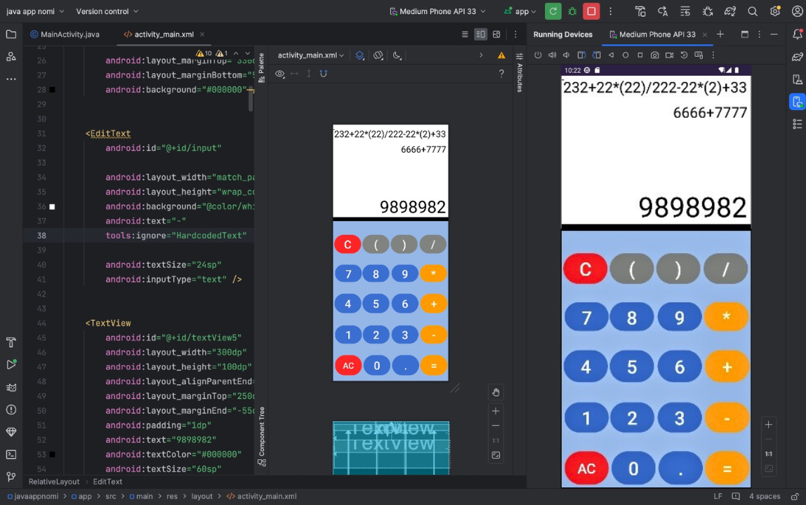

**Xml Code......**

**3 TEXT-VIEW USED(for calculation)**

**20 BUTTONS USED (for ENTER Numbers)**

**2 VIEW USED (Divide the layout into 2 parts(Color-Wise)**

<!-- l1f22bscs0122 Nauman irshad ali shah -->

<RelativeLayout xmlns:android="http://schemas.android.com/apk/res/android"

xmlns:tools="http://schemas.android.com/tools"

android:layout_width="match_parent"

android:layout_height="match_parent"

android:orientation="horizontal"

android:background="@color/white">

<View

android:id="@+id/bottomHALF"

android:layout_width="match_parent"

android:layout_height="900dp"

android:layout_marginTop="340dp"

android:background="#9BB7E3" />

<View

android:id="@+id/bottomCenter"

android:layout_width="match_parent"

android:layout_height="900dp"

android:layout_marginTop="330dp"

android:layout_marginBottom="570dp"

android:background="#000000" />

<EditText

android:id="@+id/input"

android:layout_width="match_parent"

android:layout_height="wrap_content"

android:background="@color/white"

android:text="-"

tools:ignore="HardcodedText"

android:textSize="24sp"

android:inputType="text" />

<TextView

android:id="@+id/textView5"

android:layout_width="300dp"

android:layout_height="100dp"

android:layout_alignParentEnd="true"

android:layout_marginTop="250dp"

android:layout_marginEnd="-55dp"

android:padding="1dp"

android:text="9898982"

android:textColor="#000000"

android:textSize="60sp"

tools:ignore="HardcodedText" />

<TextView

android:id="@+id/textView7"

android:layout_width="2000dp"

android:layout_height="100dp"

android:layout_alignParentStart="true"

android:layout_alignParentTop="true"

android:layout_alignParentEnd="true"

android:layout_marginStart="3dp"

android:layout_marginTop="66dp"

android:layout_marginEnd="-3dp"

android:padding="0dp"

android:text="6666+7777"

android:textColor="#000000"

android:textSize="32sp"

tools:ignore="HardcodedText" />

<TextView

android:id="@+id/textView6"

android:layout_width="2000dp"

android:layout_height="100dp"

android:layout_alignParentStart="true"

android:layout_alignParentTop="true"

android:layout_alignParentEnd="true"

android:layout_marginStart="3dp"

android:layout_marginTop="10dp"

android:layout_marginEnd="-2dp"

android:padding="1dp"

android:text="232+22*(22)/222-22*(2)+33"

android:textColor="#000000"

android:textSize="32sp"

tools:ignore="HardcodedText" />

<Button

android:layout_width="96dp"

android:layout_height="0dp"

android:layout_below="@+id/input"

android:layout_alignParentStart="true"

android:layout_alignParentBottom="true"

android:layout_marginStart="7dp"

android:layout_marginTop="786dp"

android:layout_marginBottom="16dp"

android:backgroundTint="#F14036"

tools:ignore="HardcodedText"

android:text="AC"

android:textSize="30sp" />

<Button

android:layout_width="96dp"

android:layout_height="0dp"

android:layout_below="@+id/input"

android:layout_alignParentStart="true"

android:layout_alignParentBottom="true"

android:layout_marginStart="209dp"

android:layout_marginTop="567dp"

android:layout_marginBottom="238dp"

android:backgroundTint="#446FC9"

android:text="6"

tools:ignore="HardcodedText"

android:textSize="40sp" />

<Button

android:layout_width="96dp"

android:layout_height="0dp"

android:layout_below="@+id/input"

android:layout_alignParentStart="true"

android:layout_alignParentEnd="true"

android:layout_alignParentBottom="true"

android:layout_marginStart="312dp"

android:layout_marginTop="567dp"

android:layout_marginEnd="3dp"

android:layout_marginBottom="238dp"

android:backgroundTint="#FF9F0A"

tools:ignore="HardcodedText"

android:text="+"

android:textSize="40sp" />

<Button

android:layout_width="96dp"

android:layout_height="0dp"

android:layout_below="@+id/input"

android:layout_alignParentStart="true"

android:layout_alignParentBottom="true"

android:layout_marginStart="105dp"

android:layout_marginTop="567dp"

tools:ignore="HardcodedText"

android:layout_marginBottom="238dp"

android:backgroundTint="#446FC9"

android:text="5"

android:textSize="40sp" />

<Button

android:layout_width="96dp"

android:layout_height="0dp"

android:layout_below="@+id/input"

android:layout_alignParentStart="true"

android:layout_alignParentBottom="true"

android:layout_marginStart="105dp"

android:layout_marginTop="463dp"

android:layout_marginBottom="349dp"

android:backgroundTint="#446FC9"

tools:ignore="HardcodedText"

android:text="8"

android:textSize="40sp" />

<Button

android:layout_width="96dp"

android:layout_height="0dp"

android:layout_below="@+id/input"

android:layout_alignParentStart="true"

android:layout_alignParentBottom="true"

android:layout_marginStart="209dp"

android:layout_marginTop="463dp"

android:layout_marginBottom="349dp"

android:backgroundTint="#446FC9"

tools:ignore="HardcodedText"

android:text="9"

android:textSize="40sp" />

<Button

android:layout_width="96dp"

android:layout_height="0dp"

android:layout_below="@+id/input"

android:layout_alignParentStart="true"

android:layout_alignParentEnd="true"

android:layout_alignParentBottom="true"

android:layout_marginStart="310dp"

android:layout_marginTop="463dp"

android:layout_marginEnd="5dp"

android:layout_marginBottom="349dp"

android:backgroundTint="#FF9F0A"

android:text="*"

android:textSize="40sp"

tools:ignore="HardcodedText" />

<Button

android:layout_width="96dp"

android:layout_height="0dp"

android:layout_below="@+id/input"

android:layout_alignParentStart="true"

android:layout_alignParentBottom="true"

android:layout_marginStart="7dp"

android:layout_marginTop="463dp"

android:layout_marginBottom="349dp"

android:backgroundTint="#446FC9"

android:text="7"

tools:ignore="HardcodedText"

android:textSize="40sp" />

<Button

android:layout_width="96dp"

android:layout_height="0dp"

android:layout_below="@+id/input"

android:layout_alignParentStart="true"

android:layout_alignParentBottom="true"

android:layout_marginStart="4dp"

android:layout_marginTop="357dp"

android:layout_marginBottom="451dp"

android:backgroundTint="#F14036"

tools:ignore="HardcodedText"

android:text="C"

android:textSize="40sp" />

<Button

android:layout_width="96dp"

android:layout_height="0dp"

android:layout_below="@+id/input"

android:layout_alignParentStart="true"

android:layout_alignParentEnd="true"

android:layout_alignParentBottom="true"

android:layout_marginStart="309dp"

android:layout_marginTop="357dp"

android:layout_marginEnd="6dp"

android:layout_marginBottom="451dp"

android:backgroundTint="#818380"

android:text="/"

tools:ignore="HardcodedText"

android:textSize="40sp" />

<Button

android:layout_width="96dp"

android:layout_height="0dp"

android:layout_below="@+id/input"

android:layout_alignParentStart="true"

android:layout_alignParentBottom="true"

android:layout_marginStart="206dp"

android:layout_marginTop="357dp"

android:layout_marginBottom="451dp"

android:backgroundTint="#818380"

android:text=")"

android:textSize="40sp"

tools:ignore="HardcodedText" />

<Button

android:layout_width="96dp"

android:layout_height="0dp"

android:layout_below="@+id/input"

android:layout_alignParentStart="true"

android:layout_alignParentBottom="true"

android:layout_marginStart="105dp"

android:layout_marginTop="357dp"

android:layout_marginBottom="451dp"

android:backgroundTint="#818380"

tools:ignore="HardcodedText"

android:text="("

android:textSize="40sp" />

<Button

android:layout_width="96dp"

android:layout_height="0dp"

android:layout_below="@+id/input"

android:layout_alignParentStart="true"

android:layout_alignParentBottom="true"

android:layout_marginStart="5dp"

android:layout_marginTop="567dp"

tools:ignore="HardcodedText"

android:layout_marginBottom="238dp"

android:backgroundTint="#446FC9"

android:text="4"

android:textSize="40sp" />

<Button

android:layout_width="96dp"

android:layout_height="0dp"

android:layout_below="@+id/input"

android:layout_alignParentStart="true"

android:layout_alignParentBottom="true"

android:layout_marginStart="7dp"

android:layout_marginTop="680dp"

tools:ignore="HardcodedText"

android:layout_marginBottom="129dp"

android:backgroundTint="#446FC9"

android:text="1"

android:textSize="40sp" />

<Button

android:layout_width="96dp"

android:layout_height="0dp"

android:layout_below="@+id/input"

android:layout_alignParentStart="true"

android:layout_alignParentBottom="true"

android:layout_marginStart="106dp"

android:layout_marginTop="680dp"

android:layout_marginBottom="129dp"

android:backgroundTint="#446FC9"

android:text="2"

tools:ignore="HardcodedText"

android:textSize="40sp" />

<Button

android:layout_width="96dp"

android:layout_height="0dp"

android:layout_below="@+id/input"

android:layout_alignParentStart="true"

android:layout_alignParentBottom="true"

android:layout_marginStart="209dp"

android:layout_marginTop="680dp"

android:layout_marginBottom="129dp"

android:backgroundTint="#446FC9"

tools:ignore="HardcodedText"

android:text="3"

android:textSize="40sp" />

<Button

android:layout_width="96dp"

android:layout_height="0dp"

android:layout_below="@+id/input"

android:layout_alignParentStart="true"

android:layout_alignParentEnd="true"

android:layout_alignParentBottom="true"

android:layout_marginStart="312dp"

android:layout_marginTop="680dp"

android:layout_marginEnd="3dp"

android:layout_marginBottom="129dp"

android:backgroundTint="#FF9F0A"

tools:ignore="HardcodedText"

android:text="-"

android:textSize="40sp" />

<Button

android:layout_width="96dp"

android:layout_height="0dp"

android:layout_below="@+id/input"

android:layout_alignParentStart="true"

android:layout_alignParentBottom="true"

android:layout_marginStart="109dp"

android:layout_marginTop="786dp"

tools:ignore="HardcodedText"

android:layout_marginBottom="16dp"

android:backgroundTint="#446FC9"

android:text="0"

android:textSize="40sp" />

<Button

android:layout_width="96dp"

android:layout_height="0dp"

android:layout_below="@+id/input"

android:layout_alignParentStart="true"

android:layout_alignParentBottom="true"

android:layout_marginStart="211dp"

android:layout_marginTop="786dp"

tools:ignore="HardcodedText"

android:layout_marginBottom="16dp"

android:backgroundTint="#446FC9"

android:text="."

android:textSize="40sp" />

<Button

android:layout_width="96dp"

android:layout_height="0dp"

android:layout_below="@+id/input"

android:layout_alignParentStart="true"

android:layout_alignParentEnd="true"

android:layout_alignParentBottom="true"

android:layout_marginStart="312dp"

android:layout_marginTop="786dp"

android:layout_marginEnd="3dp"

android:layout_marginBottom="16dp"

tools:ignore="HardcodedText"

android:backgroundTint="#FF9F0A"

android:text="="

android:textSize="40sp" />

</RelativeLayout>